BRAVIA 9 II | Product Information Document
v0 – 03/12/2026

Quick links within document
- Recommended Product Images & Logos  - Headline Copy  - Short Bullets | - Long Bullets  - Detailed Features  - Footnotes / Legal

Product Name
Model Number | K65XR90M2  K75XR90M2  K85XR90M2  K115XR90M2
Model Name | Sony BRAVIA 9 II True RGB 4K HDR Google TV with Gemini
Size Names | Sony 65” class (64.5” diag.) BRAVIA 9 II True RGB 4K HDR Google TV with Gemini  Sony 75” class (74.5” diag.) BRAVIA 9 II True RGB 4K HDR Google TV with Gemini  Sony 85” class (84.6” diag.) BRAVIA 9 II True RGB 4K HDR Google TV with Gemini  Sony 115” class (114.5” diag.) BRAVIA 9 II True RGB 4K HDR Google TV with Gemini
Amazon Name | Sony BRAVIA 9 II True RGB xx Inch TV, 4K Smart TV (Google TV with Gemini), RGB LED, XR Processor with AI Technology, 120Hz Television with Dolby Vision/Atmos, Anti-Glare, PS5 compatibility, KXXXR90M2, 2026 Model

Search Keywords
Sony TV, Sony BRAVIA 9 II, BRAVIA 9 II, Sony high-end TV, Sony 4K TV, 4K HDR TV, Sony True RGB TV, True RGB TV, RGB LED TV, RGB backlight TV, Sony XR TV, XR Processor TV, Smart TV, Google TV, Sony Google TV, Sony 65” TV, Sony 75” TV, Sony 85” TV, Sony 98” TV, BRAVIA 9, BRAVIA 9 II, BRAVIA 9 True RGB, BRAVIA 9 RGB LED, K65XR90M2, K75XR90M2, K85XR90M2, K98XR90M2, Immersive Black Screen Pro, BRAVIA 9 II with Google Gemini

What comes in the box
Table-top stand, AC power cord, voice remote control, batteries, quick setup guide, operating instructions

SONY PICTURES CORE¹
- 10 credits to redeem on latest release movies
- 24 months subscription of VOD movies

Recommended Audio/Video Attach
Soundbar | BRAVIA Theater Trio/Quad/Bar 9/Bar 8/Rear 9/Sub 9/Sub 8/Sub 7
Blu-Ray | UBP-X700U

Recommended Product Images & Logos

1 | 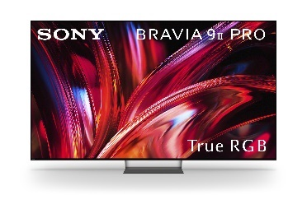 | 2 | 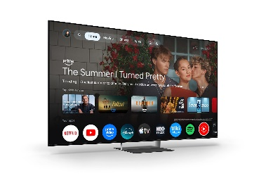 | 3 | 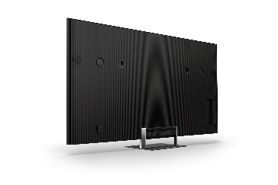
4 | 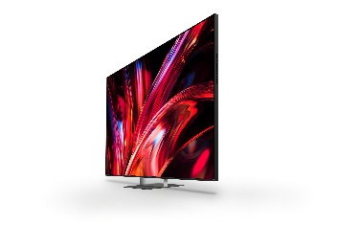 | 5 | 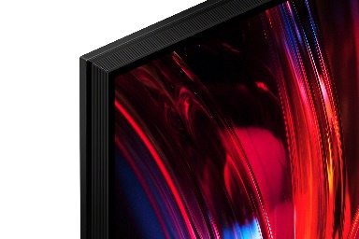 | 6 | 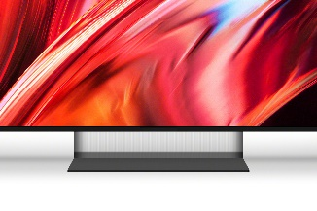
7 | 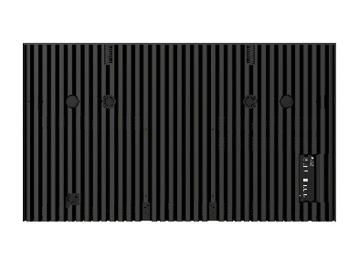 | 8 | 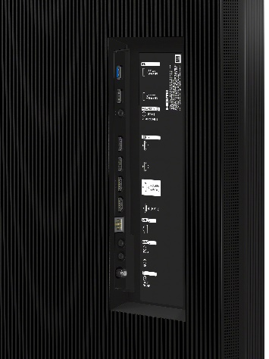 | 9 | 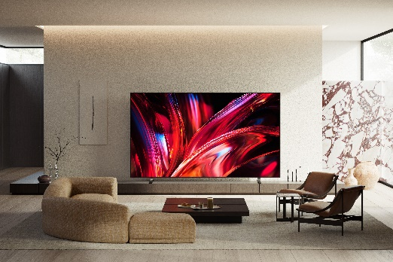
10 | 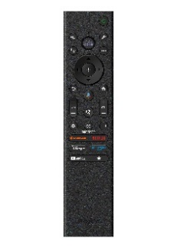 | 11 |  | 12
13 |  | 14 |  | 15

1 |  | 2 |  | 3 | 
4 |  | 5 |  | 6 | 
 |  |  |  |  | 

Headline Copy
Headline:
Our brightest and most colorful TV.

Short:
Our brightest and most colorful TV. Our flagship True RGB TV features our best anti-glare technology and wide viewing angles.

Mid:
Our brightest and most colorful TV. Our flagship True RGB TV features our best anti-glare technology and wide viewing angles, while delivering an expanded color range, deeper contrast, and precise control.

Long:
Our brightest and most colorful TV. Our flagship True RGB TV features our best anti-glare technology and wide viewing angles, while delivering maximum color range and deep contrast with precise control—faithfully reproducing content with true-to-life color and detail.

Short Bullets (please observe footnotes)
- True RGB with independently controlled red, green, and blue LEDs delivers pure, vibrant color with an expanded color range.
- True RGB combines QD-OLED color range with Mini LED brightness for exceptional color accuracy.
- X-Wide Angle Pro keeps color and contrast consistent from virtually any seat in the room.
- Immersive Black Screen Pro reduces reflections, so the picture stays clear even in bright rooms.
- XR Processor™ with AI scene recognition optimizes color, contrast, and clarity in real time.
- XR Clear Image™ restores detail and reduces noise in older and lower-resolution content.
- XR Contrast Booster increases peak brightness while deepening blacks for stronger contrast.
- XR Motion Clarity™ keeps sports, action scenes, and gameplay smooth and blur-free.
- RGB sensing detects LED performance in real time and optimizes brightness for accurate color reproduction.
- My Cinema presets optimize picture and sound for different viewing environments.
- Acoustic Multi-Audio+™ with Beam Tweeter delivers cinematic surround sound aligned with the picture.
- 3D Surround Upscaling converts stereo audio into immersive 3D sound.
- Voice Zoom 3™ with AI enhances dialogue clarity in every scene.²
- Direct TV Connection allow easy expansion with select subwoofers, rear speakers, or both.³
- Quick Settings soundbar control lets you adjust compatible soundbars directly from the TV.
- Bluetooth headphone control allows playback and volume adjustments from your headphones.⁴
- SONY PICTURES CORE™ includes movies with IMAX® Enhanced and Pure Stream quality.^{1,5,6}
- Dolby Vision®, Dolby Atmos®, IMAX® Enhanced, and DTS:X® support brings cinematic picture and sound home.^{5,7}
- Studio Calibrated picture modes reproduce picture quality as the creator intended.
- Gemini on Google TV™ helps you find movies and shows faster with voice search and recommendations.⁸
- Apple AirPlay® 2 support lets you stream easily from iPhone, iPad, or Mac.⁹
- Google Cast™ built in lets you cast movies, shows, and apps from compatible devices.¹⁰
- Hands-free Gemini voice control lets you search and control the TV with your voice.¹¹
- Auto HDR Tone Mapping and Auto Genre Picture Mode optimize picture quality for PS5® gaming.¹²
- Game Menu 2 puts all gaming picture settings and assist features in one place.
- HDMI 2.1 features including 4K/120, VRR, and ALLM deliver responsive high-performance gaming.¹³
- PS Remote Play streams PlayStation® games directly to your BRAVIA TV.¹⁴
- Harmonic Presence design features clean lines with integrated cable management for a clutter-free setup.
- Mirage Stand uses slim steel and a transparent lens panel to create a floating look.¹⁸
- Inclusive remote design with Remote Finder improves accessibility with larger buttons and tactile shapes.
Long Bullets (please observe footnotes)
- True RGB, the future of color – Powered by a newly evolved Backlight Master Drive, Sony's True RGB drives three-color LEDs independently for unprecedented color volume, precise color gradation, and a significantly wider viewing angle.
- A new era of uncompromising color accuracy – Sony unites the color range of our flagship QD-OLED with the high brightness of a Mini LED. This breakthrough enables a new level of color volume and the ability to render even more accurate colors.
- See the hidden depths like never before – From the brightest peak to the darkest shade, Sony's True RGB faithfully reproduces even the finest tonal details. It brings the full depth of the story vividly to life on screen.
- Color, faithfully reproduced – Sony's True RGB sensing function detects LED operating efficiency in real time and optimizes brightness accordingly, so the TV consistently reproduces the color tones of the input video with high fidelity.
- Same stunning picture, any seat – With X-Wide Angle Pro, color and contrast stay vivid and natural from the side as well as the front, giving the whole room a true cinema view.
- Watch uninterrupted, even in daylight – From morning light to evening glare, Immersive Black Screen Pro keeps the picture clear. Reflections are minimized by a unique screen treatment, letting you stay absorbed in the film without distraction, whatever the time of day.
- Smarter picture in real time – The XR Processor uses AI scene recognition to optimize color, contrast, and clarity in every frame for lifelike realism.
- Make everything you watch look closer to 4K – XR Clear Image AI restores lost detail and reduces noise for a clearer, more natural image.
- Contrast intensified. Depth amplified – XR Contrast Booster precisely balances light across the screen, adjusting brightness for higher peaks in glare and deeper blacks in shadow.
- Even fast-moving action stays smooth, bright and clear – XR Motion Clarity analyzes movement across several frames and precisely synchronizes the backlight with on-screen motion so you see clear, bright images, however fast the action.
- My Cinema presets. Tailored to the moment – Choose from cinema-optimized picture and sound presets designed for various viewing environments. These presets adjust your TV for the best movie-watching experience with just a single step.
- Cinema-like surround sound, in harmony with the picture – Feel like you're in the cinema. Acoustic Multi-Audio+™ with Beam Tweeter at the top delivers cinematic surround sound. Every sound comes from exactly the right place.
- From stereo to expansive 3D surround, wider and clearer – Ordinary sound becomes extraordinary. With our evolved 3D Surround Upscaling including proprietary virtualizer, stereo expands into wider, more precise 3D audio, crisper, clearer, and more immersive than ever.
- Crystal clear voice. With AI technology – No more muffled voices. Our Voice Zoom 3™ recognizes human dialogue through AI machine learning and amplifies or reduces its volume so even small dialogue sounds loud and clear.²
- Easily expand your cinema: Direct TV connection – Add just what you want, subwoofer, rear speakers, or both, directly to your BRAVIA TV for ideal cinema sound. Enjoy stronger bass, greater impact, and a wider surround field, transforming movies into a bigger, more cinematic experience.³
- Control your BRAVIA Theater effortlessly – Easily control features such as sound field and volume using just the TV remote. With an integrated UI, soundbar sound settings automatically appear on the BRAVIA Quick Settings menu.
- Touch and control from your headphones – Control your BRAVIA TV with a tap. Play, pause, skip, or adjust the volume directly from your connected Bluetooth headphones.⁴
- Movies included with your TV in premium picture quality – Access Sony Pictures Core with Pure Stream and the largest IMAX® Enhanced collection included with BRAVIA.^{1,5,6}
- Bring cinematic standards home – Our TV supports the rigorous standards of Dolby Vision®, Dolby Atmos®, IMAX® Enhanced, and DTS:X® for an unbelievably atmospheric and immersive viewing experience.⁷
- Authentic picture. From the studio to your screen – Sony's Studio Calibrated modes deliver pictures that stay faithful from studio to screen, across your favorite streaming platforms.
- Find what to watch faster with Gemini on Google TV™ – Just ask Gemini to get personalized recommendations and browse movies and shows from all your apps in one place.^{8,11}
- Compatible with Apple AirPlay 2 – Stream effortlessly to your TV from your iPhone, iPad or Mac. Watch movies from apps or Safari. Share photos with friends in the room.⁹
- Google Cast™ – Cast content from your phone or tablet directly to your TV.¹⁰
- Chat with Gemini hands-free to find the perfect movie or show – Tell Gemini what you're in the mood for and get personalized recommendations. You can also find content, open apps, and control compatible smart home devices, all without reaching for the remote.^{8,11}
- Take your PS5® gaming to the next level – Auto HDR Tone Mapping and Auto Genre Picture Mode optimize picture quality for gaming and streaming.¹²
- All your gaming essentials in one place – Game Menu 2 lets you check your status, fine tune settings and access assist functions from one place. You can even search for YouTube videos and switch to Multi-View in an instant.
- Level up your gaming with HDMI 2.1 features – With 4K/120, VRR, and ALLM, BRAVIA delivers smooth, responsive, high-performance gameplay.¹³
- Stream PlayStation® games to your BRAVIA TV – The PS Remote Play app lets you control your PS5®, PS5® Pro or PS4 console from another room or location.¹⁴
- Harmonic Presence. Blends flawlessly into your space. – Harmonic Presence defines the flagship. A design that blends with your space, enhanced by a wave-textured bezel and a transparent center stand that creates a floating, cable-free look. Even when the screen rests as décor.
- The Mirage Stand. Subtle, seamless – Strength with lightness. The Mirage Stand combines slim steel with a transparent lens panel, creating the illusion of floating.¹⁸
- A remote for everyone – An inclusive remote with bigger buttons, distinct shapes, and clearer spacing for easier navigation by touch. A wave-textured back improves grip and comfort, while Remote Finder helps locate the remote.
- Balancing environment and entertainment – Eco Dashboard puts all your energy efficiency settings in one place and can even monitor your power consumption for optimum efficiency.

Detailed Features (please observe footnotes)

True RGB, the future of color  Powered by a newly evolved RGB Backlight Master Drive Pro built on two decades of innovation, Sony's True RGB is three independently controlled RGB LEDs. It delivers unprecedented color volume, precise color gradation, and significantly wider viewing angles that enhance the movie-watching experience even further. | 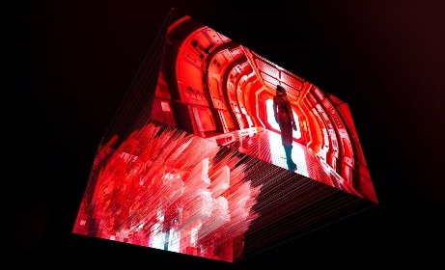

A new era of uncompromising color accuracy  Sony unites the color range of our flagship QD-OLED with the high brightness of a Mini LED. This breakthrough enables a new level of color volume and the ability to render even more accurate colors. | 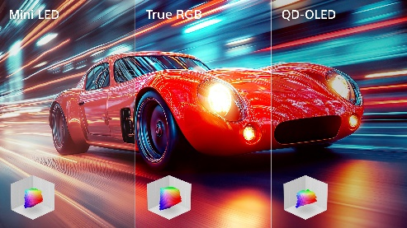

See the hidden depths like never before  From the brightest peak to the darkest shade, Sony's True RGB faithfully reproduces smooth color gradation in even the finest tonal details. It brings the full depth of the story vividly to life on screen. | 

Smarter picture in real time  The XR Processor powers the BRAVIA 9 II, using AI scene recognition to optimize color, contrast, and clarity. Every frame is analyzed and refined for lifelike realism. | 

Crystal clear pictures with AI upscaling technology  XR Clear Image AI intelligently upscales your  favorite content to 4K by restoring details lost during the  transmission process. Dynamic frame analysis and zone division work together to minimize noise introduced during signal transmission, resulting  in a clearer and more natural image. | 

Contrast intensified. Depth amplified.  XR Contrast Booster precisely balances light across the screen, adjusting brightness for higher peaks in glare and deeper blacks in shadow. Peak brightness is higher than ever for sublime depth and detail. | 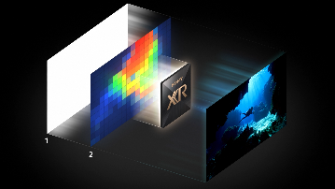

Even fast-moving action stays smooth, bright and clear  Forget about blur. XR Motion Clarity™ analyzes movement across several frames and precisely synchronizes the backlight with on-screen motion so you see clear, bright images, however fast the action. | 

Individually calibrated. Consistently flawless.  Behind every BRAVIA TV is meticulous craft. By factory calibrating each panel one by one, we remove variations and ensure consistent, high-quality performance you can rely on. | 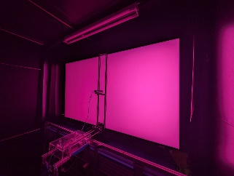

Cinema-like surround sound, in harmony with the picture  Feel like you're in the cinema. Acoustic Multi-Audio+™ with Beam Tweeter at the top delivers cinematic surround sound. Every sound comes from exactly the right place. | 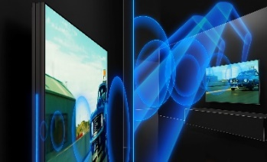

From stereo to expansive 3D surround  Ordinary sound becomes extraordinary. With our proprietary 3D Surround Upscaling, stereo sound expands into wider, more precise 3D audio, crisper, clearer, and more immersive than ever. | 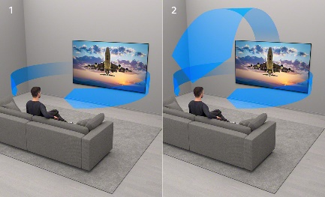

Crystal clear voice. With AI technology.  No more muffled voices. Our Voice Zoom 3™ recognizes human dialogue through AI machine learning and amplifies or reduces its volume so even small dialogue sounds loud and clear. Works with our home theater products too.² | 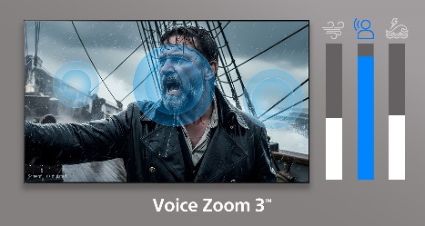

Direct Connect with BRAVIA Theater Sub/Rear  Add just what you want, subwoofer, rear speakers, or both, directly to BRAVIA for your ideal cinema sound. Enjoy stronger bass, greater impact, and a wider surround field, transforming movies into a bigger, more cinematic experience. An easy upgrade without the complexity of a full home theater system.³ | 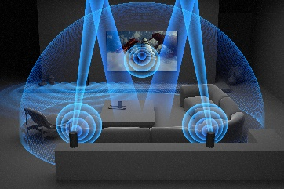

Control your BRAVIA Theater​ effortlessly  Easily control features such as sound field and volume using  just the TV remote. With an integrated UI, soundbar sound  settings automatically appear on the BRAVIA Quick Settings  menu. | 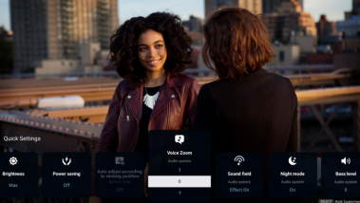

Touch and control from your headphones  Control your BRAVIA TV with a tap. Play, pause, skip, or adjust the  volume directly from your connected Bluetooth headphones, so you  can stay immersed in your content without reaching for the remote.⁴ | 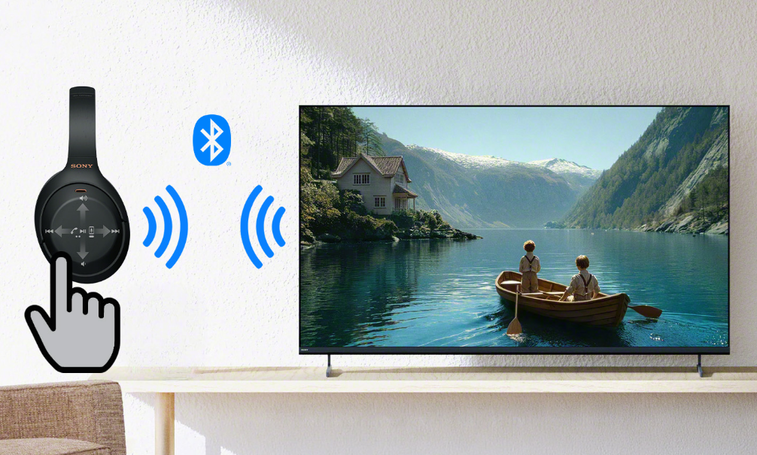

Same stunning picture from any seat  With X-Wide Angle Pro, color and contrast stay vivid and natural from the side as well as the front, giving the whole room a true cinema view. | 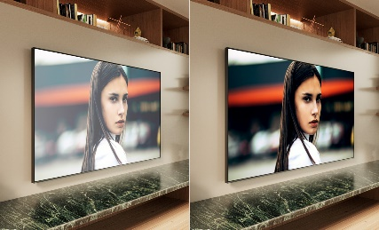

Watch uninterrupted even in daylight  From morning light to evening glare, Immersive Black Screen Pro keeps the picture clear. Reflections are minimized by a unique screen treatment, letting you stay absorbed in the film without distraction, whatever the time of day. | 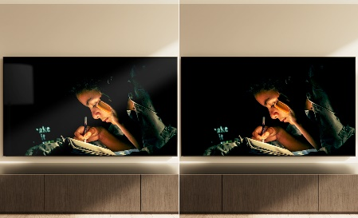

Color, faithfully reproduced  Sony's True RGB features the sensing function that detects LED operating efficiency in real time and optimizes brightness accordingly. This allows the TV to consistently reproduce the color tones of the input video with high fidelity. | 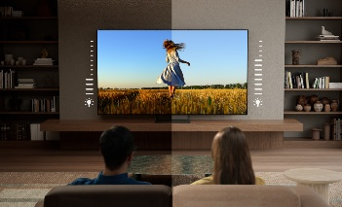

Bring cinematic standards home  Experience truly unforgettable movies at home. Our TV supports  the rigorous standards of Dolby Vision® and Dolby Atmos® for an  unbelievably atmospheric and immersive viewing experience.⁷ | 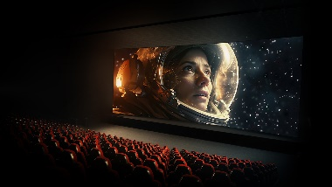

Authentic picture. From the studio to your screen  Step closer to the filmmaker's vision. Sony's Studio Calibrated modes deliver pictures that stay faithful from studio to screen, across your favoritestreaming platforms. | 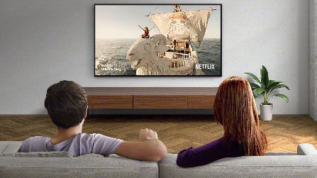

Epic Quality. Limitless Entertainment.  Explore a huge selection of the latest blockbusters, classic hits,  and hidden gems from Sony Pictures. Choose favorites to add to  your collection included with your BRAVIA TV. Experience next-level picture and sound quality with Pure Stream technology and  IMAX Enhanced movies on SONY PICTURES CORE.^{1,6} | 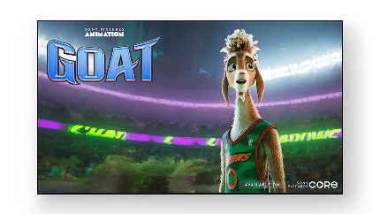

Find what to watch faster with Gemini on Google TV™  Just ask Gemini for personalized recommendations and browse movies and shows from all your apps in one place. Chat hands-free to refine suggestions, get helpful insights, open apps, play music, and control compatible smart home devices, all without reaching for the remote.^{8,11} | 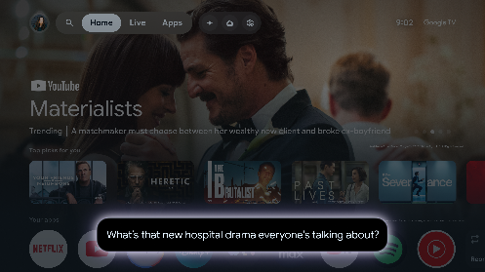

Compatible with Apple Airplay 2  Stream effortlessly to your TV from your iPhone, iPad or Mac. Watch movies from apps or Safari. Share photos with friends in the room.⁹ | 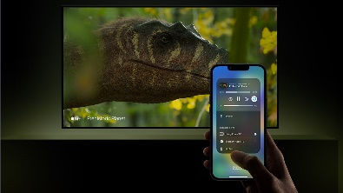

Google Cast™  Stream from your device. Easily cast movies, shows, photos, and more from your phone or tablet, right to your TV.¹⁰ | 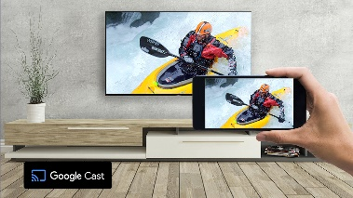

My Cinema presets. Tailored to the moment  Choose from cinema-optimized picture and sound presets designed for various viewing environments, such as the time of day and room environment. These presets adjust your TV for the best movie-watching experience with just a single step. | 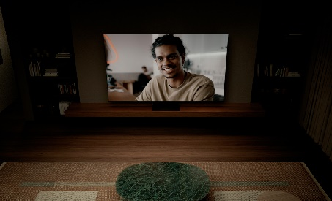

One place for all your game settings  Never has it been easier to fine-tune your game status, settings and assist functions. All the essentials are at your fingertips for ease and comfort. | 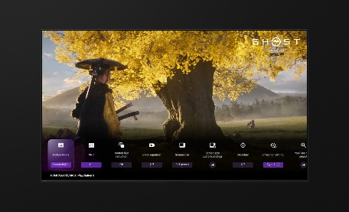

Stream PlayStation® games to your BRAVIA TV  Control your PlayStation console remotely wherever you have a compatible BRAVIA TV connected to the internet. The PS Remote Play app lets you control your PS5®, PS5® Pro or PS4 console from another room or location like a friend's house.¹⁴ | 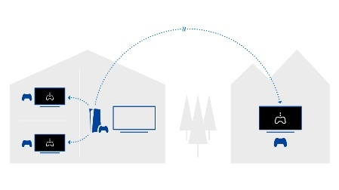

Auto HDR Tone Mapping  Auto HDR Tone Mapping instantly optimizes HDR settings during your PS5® and PS5® Pro console initial setup. Even in dark shadow and bright highlights, you’ll see fine details and true colors.^{12,16} | 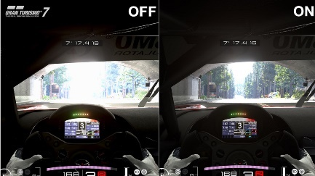

Auto Genre Picture Mode  Your BRAVIA TV automatically switches into Game Mode with PS5® and PS5® Pro consoles to minimize lag and maximize responsiveness. It switches back to Standard Mode when watching movies for more expressive scenes.^{12,16} | 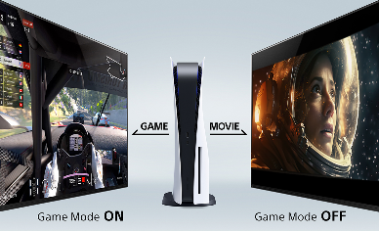

Level up your gaming with HDMI 2.1 features  BRAVIA TVs deliver a thrilling gaming experience with support for HDMI 2.1 features 4K/120, VRR, ALLM, and SBTM. With 4K/120 you get consistent 120fps in 4K resolution giving you the advantage in high-intensity gaming. Variable Refresh Rate (VRR) allows the TV to dynamically match frame rate of the gaming device, enabling smoother gameplay without stuttering delays or screen tearing. Auto Low Latency Mode (ALLM) supports more responsive gameplay by enabling the TV to automatically switch to low latency mode whenever a gaming device is connected.¹³ | 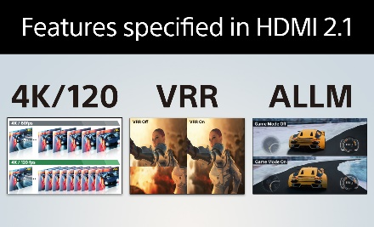

Harmonic Presence. Fits seamlessly into your space.  Harmonic Presence defines the flagship. A design that blends with your space, enhanced by a wave-textured bezel and a transparent center stand that creates a floating, cable-free look. Even when the screen rests as décor. | 

The Mirage Stand. Subtle, seamless  The Mirage Stand combines slim steel with a transparent lens panel, concealing cables completely from view so the TV appears to float.¹⁸  Available on 65”, 75”, and 85” class screen sizes only. | 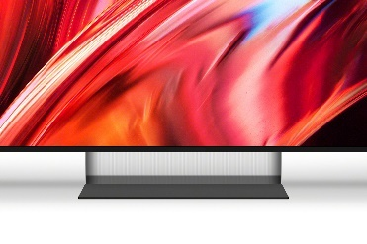

A remote for everyone  A newly designed remote created with feedback from end users. It features bigger buttons, distinct shapes, and clearer spacing for easier navigation by touch. A new wave-textured back improves grip and comfort, while the Remote Finder function helps you quickly locate it. Valuable for all users, including those who are visually impaired. | 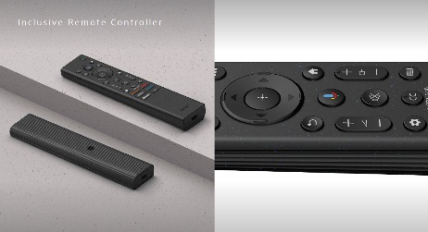

Balancing environment and entertainment  Easily change eco settings, individually or in one go. Eco  Dashboard 2 puts everything conveniently in one place and  can even monitor your power consumption for optimum  efficiency. | 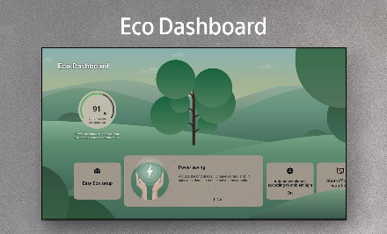

Footnotes / Legal

1 Purchase an eligible TV and register for SONY PICTURES CORE™ by February 23, 2028 to be eligible for promotion offers. Available movies subject to change. Terms and conditions apply, for full details see https://sony.net/sony-pictures-core. Network services, content, and operating system and software of product may be subject to separate or third-party terms and conditions and changed, interrupted, or discontinued at any time and may require fees, registration, and credit card information.
2 Voice Zoom 3 works with compatible BRAVIA TVs. For full compatibility list: https://www.sony.net/hav_faq.
3 This function works with select compatible BRAVIA Home Theater products (sold sep). Product availability varies by countries/regions. https://www.sony.net/hav_faq. Voice Zoom and simultaneous audio output to Bluetooth devices are disabled when Direct Connect to BRAVIA is active. When Content Type on BRAVIA is 'Game' or 'PC', there may be instances where the audio is delayed in relation to the picture in order to prioritize low latency for the picture.
4 Interoperability and compatibility among Bluetooth® devices vary.
5 IMAX Enhanced content enables full IMAX Enhanced experience with compatible streaming services such as SONY PICTURES CORE (formerly BRAVIA CORE), or compatible content device connected via HDMI input (sold separately).
6 User must setup broadband network environment. By default, Pure Stream setting is turned OFF and must be turned ON in BRAVIA CORE settings. BRAVIA CORE offers streaming between 30Mbps-80Mbps once user turns ON Pure Stream. To access Pure Stream at 30Mbps, user must have a minimum internet speed of 43Mbps over Wi-Fi. To access highest quality Pure Stream available at 80Mbps user must have minimum internet speed of 115Mbps over Wi-Fi. Subject to user’s network operator’s video streaming restrictions, BRAVIA CORE automatically selects the best bitrate as following with adaptive streaming functionality based on the internet speed available.
7 Dolby Vision/Atmos and DTS:X content compatible with streaming services or compatible content device connected via HDMI input (sold separately).
8 The Gemini for TV experience is optimized for large screen experiences. Results may vary. Check responses for accuracy. Available in select countries, languages, and to users 18+. Learn more at g.co/tv/gemini. Gemini requires a software update and is available on select models only.
9 This Sony TV is compatible with AirPlay 2 and HomeKit. iOS 12.2 or later or macOS 10.14.4 or later is required. Apple ID account required. Subscriptions may be required to access certain content.
10 Google Cast compatibility dependent on app.
11 User must accept Google Terms of Service (http://www.google.com/policies/terms/), Google Play Terms of Service (https://play.google.com/intl/en-US_us/about/play-terms/index.html), and Privacy Policy (http://www.google.com/policies/privacy/) to use this product. User consents to a mandatory software update at set-up and such other additional updates that may be required in the future by Google and/or Sony. User must connect to a Google Account to use certain advertised features, including voice to activate linked apps, and install certain apps and operating software during setup. Use of this product without connecting to a Google Account allows only basic features and certain apps. Features and specifications are subject to change without notice. Wireless connectivity requires 802.11 home network (802.11n recommended). Network services, content, operating system, and software of this product may be subject to separate or third-party terms and conditions and changed, interrupted, or discontinued at any time and may require fees, registration, and credit card information. Apps must be compatible with this product. App availability varies by region and device.
12 To activate Auto HDR Tone Mapping, must enable feature when pairing PS5 to the TV for the first time; or will need to perform factory reset on PS5 and enable the feature during initial setup. Auto Genre Picture Mode works when Auto Picture Mode on the TV is set to ON. Both features are supported only when PS5 and TV are directly connected, or via compatible Sony soundbar.
13 Game title supporting VRR and/or 4K/120fps required. VRR results may vary depending on the game you're playing. If enabling VR results in any unexpected visual effects, you can turn it off at any time.
14 A PS4™ or PS5® console is required to stream your games to other devices. PS Remote Play can be used with a mobile data connection or Wi-Fi. Broadband internet with at least 5Mbps is required. For a better PS Remote Play experience, a high-speed connection of at least 15Mbps is recommended using either Wi-Fi or mobile data connection. Titles that require a VR headset (PlayStation®VR or PlayStation®VR2) or additional peripherals (other than a DUALSHOCK®4, DualSense™, or DualSense Edge™ wireless controller) are not compatible with PS Remote Play.
16 Gran Turismo 7 ©2023 Sony Interactive Entertainment Inc. Developed by Polyphony Digital Inc. “Polyphony Digital logo”, “Gran Turismo” and “GT” are registered trademarks of Sony Interactive Entertainment Inc. Manufacturers, cars, names, brands and associated imagery featured in this game in some cases include trademarks and/or copyrighted materials of their respective owners. Any depiction or recreation of real world locations, entities, businesses, or organizations is not intended to be or imply any sponsorship or endorsement of this game by such party or parties. All rights reserved.
17 ©2026 Sony Interactive Entertainment Inc.
18 Mirage Stand Applicable TV Models: K85XR90M2, K75XR90M2, K65XR90M2, K85XR70M2, K75XR70M2, K65XR70M2, K55XR70M2, K50XR70M2

19 The ratio and part of recycled material usage may vary by size, region and country. Please check the individual product for explicit ratio.
20 This TV uses at least 28% recycled material and allocates 23% biomass-based renewable material (mass balance approach).​
21 Recycled materials are used for the back cover on the 65-inch model only.

© 2026 Sony Electronics Inc. All rights reserved. Reproduction in whole or in part without written permission is prohibited.

Sony, BRAVIA, and the Sony logo are trademarks of Sony Corporation. Google TV is the name of this device’s software experience and a trademark of Google LLC. Google, Google Cast, YouTube and YouTube Music are trademarks of Google LLC. “PlayStation Family Mark,” “PlayStation,” “PS5 logo” and “PS5” are registered trademarks or trademarks of Sony Interactive Entertainment Inc. All other trademarks are trademarks of their respective owners. Features and specifications are subject to change without notice. Screen images simulated.

