BRAVIA Theater Trio | Product Information Document
V1 – 02/16/2026

Quick links within document
- Recommended Product Images & Logos  - Headline Copy  - Short Bullets | - Long Bullets  - Detailed Features  - Footnotes / Legal

Product Name
Model Number | HT-A8
Model Name | Sony BRAVIA Theater Trio, Dolby Atmos®/DTS:X® compatible
Amazon Name | Sony BRAVIA Theater Trio, Dolby Atmos®/DTS:X® compatible, 360 Spatial Sound Mapping, Dual Subwoofer Capability, Bluetooth, HT-A8

Search Keywords
Sony BRAVIA Theater Trio, Sony Theater Trio, Theater Trio, BRAVIA Theater Trio, BRAVIA Trio, Sony BRAVIA Trio, Sony Home Theater Trio, BRAVIA Home Theater Trio, HT-A8, HTA8, BRAVIA Theatre Trio, Sony BRAVIA Theatre Trio, Sony Theatre Trio, Theatre Trio, HTA8, HTA-8, HT-A8, BRAVIA Trio

What comes in the box
AC Power Cord, Remote Control, Batteries for Remote Control, HDMI Cable, Wall Mounting Bracket, Auto Calibration Microphone, Feet, Reference Guide

Recommended BRAVIA TVs
BRAVIA 9 II, BRAVIA 8 II, BRAVIA 8, BRAVIA 7 II, BRAVIA 5

Recommended Product Images & Logos

1 |  | 2 |  | 3
4 |  | 5 |  | 6 | 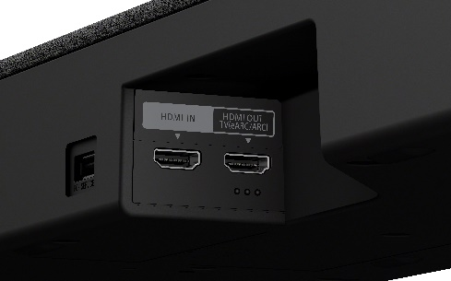
7 | 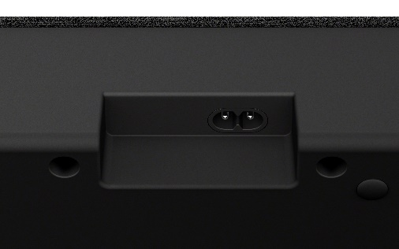 | 8 |  | 9
10 |  | 11 |  | 12
13 |  | 14 |  | 15

1 |  | 2 |  | 3 | 
4 |  | 5 |  | 6 | 
7 |  |  | 

Headline Copy
Headline:
Blockbuster sound—built for the big screen.
Short:
Blockbuster sound—built for the big screen. Our flagship model, BRAVIA Theater Trio, expands sound far beyond the screen with 360 Spatial Sound Mapping.¹
Mid:
Blockbuster sound—built for the big screen. Our flagship model, BRAVIA Theater Trio, expands sound far beyond the screen. Perfect for today's ultra-large TVs, its three-unit design and 360 Spatial Sound Mapping generate a vast, room-filling soundstage. ¹

Long:
Blockbuster sound—built for the biggest screens. Our flagship model, BRAVIA Theater Trio, expands sound far beyond the screen. Perfect for today's ultra-large TVs, its three-unit design and 360 Spatial Sound Mapping generate a vast, room-filling soundstage—bringing cinematic scale and immersion into your living room. ¹

Short Bullets (please observe footnotes)
- Introducing a simple three-unit home theater system with wireless front speakers that matches the scale of even the biggest screen.
- Created in close collaboration with Sony Pictures Entertainment for studio-crafted sound true to filmmaker’s' intent.
- Experience the ultimate in home surround with 360 Spatial Sound Mapping creating up to 24 phantom speakers.¹
- Get cinematic surround experience calibrated specifically for your room with Sound Field Optimization.
- Use the included USB-C calibration microphone to automatically optimize audio based on your room’s acoustics.⁶
- Get premium streaming experience with support for Dolby Atmos®, DTS:X®, and IMAX® Enhanced certification.^{2,7}
- Enjoy wireless music streaming from your smartphone with Bluetooth® technology.⁵
- Your stereo content is up-mixed into rich surround sound with AI Sound Separation for clearer voices.
- Expand your setup with dual subwoofers and rear speakers for an even more immersive experience.⁸
- Hear immersive overhead audio with enlarged up-firing speakers and crystal-clear dialogue from the X-Balanced center speaker.
- Give your favorite music a boost as DSEE Ultimate restores acoustic details for a richer listening experience.
- Use BRAVIA Connect app to easily set up, calibrate, and control your system from your smartphone.⁴
- Pair with compatible BRAVIA TVs to take advantage of Voice Zoom 3™ for enhanced dialogue.³
- Supports video formats 4K HDR, 8K HDR, Dolby Vision® and HDMI 2.1 gaming features 4K120, VRR, ALLM. ^{2, 11}
- Space-saving design allows the soundbar to sit tidily over the TV stand for an integrated look.⁹

Long Bullets (please observe footnotes)
- Three-unit System. One Immersive Experience – Introducing a simple home theater system with wireless front speakers that matches the scale of even the biggest screen, keeping your room tidy while filling it with surround sound.
- Sound shaped with Sony Pictures Entertainment – Created in close collaboration with Sony Pictures Entertainment, this system brings studio-crafted sound into your home, capturing the emotion and detail envisioned by filmmakers.
- Rewriting the rules of surround sound – Go beyond conventional surround sound with a surround field that stretches wider than the screen, delivering cinematic immersion that pulls you into every scene.
- Ultimate surround with 360 Spatial Sound Mapping – Experience the ultimate in home surround with up to 24 phantom speakers in a cinema layout, simulating both direct and reflected sound to recreate the acoustic characteristics of a real cinema. ¹
- Sound Field Optimization – Enjoy a cinematic surround experience calibrated specifically for your room, ensuring every seat is the best seat in the house.
- Sound tuned perfectly for your room – Using the included USB Type-C microphone, connect to your mobile device to allow accurate automatic calibration to tailor the audio output to its unique acoustic requirements.⁶
- Sound straight from cinema – Get premium streaming experience with support for Dolby Atmos®, DTS:X®, and IMAX® Enhanced certification for a truly premium experience.^{2,7}
- Wireless Bluetooth® streaming – Enjoy wireless music streaming from your smartphone and other devices.⁵
- Elevated upmixed audio experience – Sony's upmixer transforms stereo content into rich 3D surround sound, with AI Sound Separation detecting and clarifying human voices.
- Build a Bigger Home Theater – Elevate your setup with dual subwoofers for deep, powerful bass and rear speakers for a more immersive surround field.⁸
- Enhanced sound from every direction – Newly enlarged up-firing speakers and 360 Spatial Sound Mapping create immersive overhead audio, while the center speaker's X-Balanced design delivers punchy bass, reduced distortion, and crystal-clear dialogue. ¹
- Give your favorite music a boost – DSEE Ultimate up-mixes compressed digital music, restoring acoustic details for a richer listening experience.
- Do it all with BRAVIA Connect app – The BRAVIA Connect app guides you step by step, covering everything from connection to calibration and everyday control.⁴
- BRAVIA Theater and select BRAVIA TVs, the perfect pair – Pair with compatible BRAVIA TVs to control soundbar settings with a single remote and take advantage of Voice Zoom 3™ for clear, natural dialogue.³
- Premium video & gaming formats – Enjoy support for 4K HDR, 8K HDR, and Dolby Vision® video formats alongside HDMI 2.1 gaming features including 4K120, VRR, and ALLM for a seamless, high-performance experience^{2, 11}
- Space-saving Design – The supplied spacer allows the soundbar to sit tidily over the TV stand for an integrated look that saves you space.⁹

Detailed Features (please observe footnotes)

Three-unit System. One Immersive Experience

Introducing a simple home theater system that matches the scale of big screens. With wireless links to the front, left, and right speakers, you get a streamlined setup that keeps your room tidy while filling it with surround sound. Left and right speakers envelop you completely in immersive sound, while a dedicated center ensures dialogue is clear, making every scene feel cinematic.

Sound shaped with Sony Pictures Entertainment  Created in close collaboration with Sony Pictures Entertainment, this system brings studio-crafted sound into your home – capturing the emotion and detail envisioned by filmmakers. ¹⁹ | 

Rewriting the rules of surround sound  Go beyond conventional surround sound. By combining physical and phantom speakers, the BRAVIA Theater Trio creates a surround field that stretches wider than the screen, delivering cinematic immersion that pulls you into every scene. | 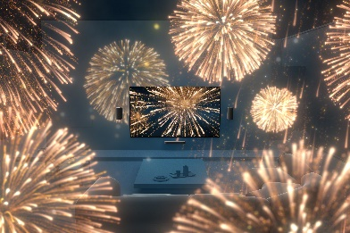

Ultimate surround with 360 Spatial Sound Mapping  Inspired by our film production experience, 360 Spatial Sound Mapping creates up to 24 phantom speakers positioned based on a cinema layout, achieving wider coverage so more people can enjoy the same immersive experience. By simulating both direct and reflected sound, it captures the acoustic characteristics of a real cinema to recreate its immersive atmosphere. Add optional wireless rear speakers for an even more expansive sound stage—bringing every film closer to the way it was meant to be heard. ¹ | 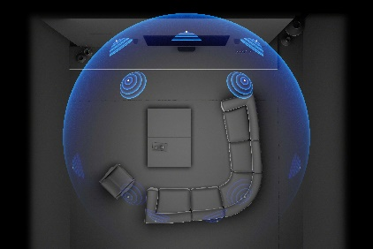

Sound Field Optimization  Enjoy a cinematic surround experience calibrated specifically for your room. Sound Field Optimization ensures that every seat is the best seat in the house, regardless of your room's unique acoustics. | 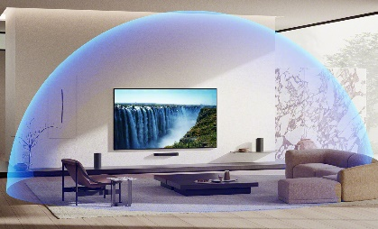

Calibration Microphone

This included USB Type-C microphone connects to your mobile device to allow accurate automatic calibration that matches your room characteristics. A simple step during setup measures frequency, phase, and delay characteristics in your viewing space, to tailor the audio output to its unique acoustic requirements.⁶

Sound straight from cinema  Bring the authentic atmosphere of the movie theater into your living room. The BRAVIA Theater Trio supports industry-standard formats like Dolby Atmos® and DTS:X®,² and it is IMAX® Enhanced certified for a truly premium experience.⁷ | 

Wireless Bluetooth® streaming  Enjoy wireless music streaming from your smartphone and other devices with Bluetooth® technology.⁵ | 

Elevated upmixed audio experience to deliver rich surround sound  Sony’s upmixer delivers rich surround sound even from stereo content. Its innovative algorithm extracts and redistributes individual audio objects to immerse you in 3D sound. While upmixing, AI Sound Separation processing detects human voices and makes them sound clearer. | 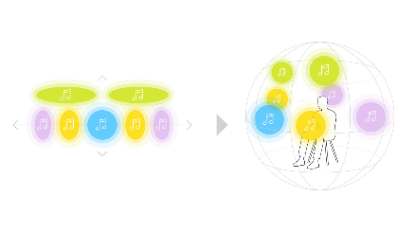

Amplify the moment with Multi Stereo  Multi Stereo enhances your listening experience by playing the same sound from both front (L/R/Center) and rear speakers, creating a full-room sound boost. Feel the sound reverberate with greater intensity, amplifying every moment.⁸ | 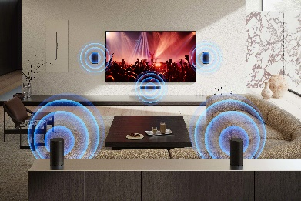

Build a Cinematic Home Theater Experience  Elevate your home theater sound with dual subwoofers for deep, powerful bass and rear speakers for an immersive surround field. Bring cinematic scale and impact to every movie night. | 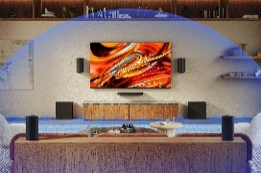

Materials engineered for pure sound

An aluminium ring and copper cap are coupled with the lightweight driver cone to suppress harmonic distortion. Combined with the powerful magnet, you'll enjoy cleaner, more neutral sound across all frequencies.

Flexible setup for any layout  Use the BRAVIA Theater Trio wall-mounted or free-standing–whichever fits your space. | 

Lose yourself in premium music quality  Bring your music to life as never before. Enjoy tracks the way the artists intended with High-Resolution Audio.¹² | 

Give your favorite music a boost  Enjoy tracks like you’re in the recording studio with the artist. Digital Sound Enhancement Engine (DSEE) up-mixes compressed digital music, restoring acoustic details for a richer listening experience. | 

Do it all with BRAVIA Connect app  The BRAVIA Connect smartphone app guides you step by step, covering everything from connection to calibration and everyday control.⁴ | 

BRAVIA Theater and select BRAVIA TVs, the perfect pair  Pair BRAVIA Theater with a compatible BRAVIA TV for an unmatched audio-visual experience. Control soundbar settings on the TV's Quick Settings menu and adjust volume and sound settings with a single remote. When paired with select BRAVIA TVs, take advantage of Voice Zoom 3™, which uses AI to improve dialogue and ensure people’s voices are always loud and clear.³ | 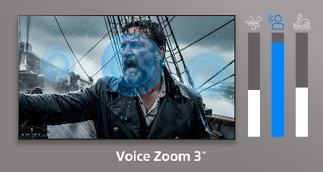

Space-saving Design  The supplied spacer allows the soundbar to sit tidily over the TV stand for an integrated look that saves you space.⁹ | 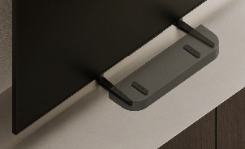

Environment in mind  Sony’s home audio products are designed not only for excellent sound experiences but also with the environment in mind. We are committed to using less virgin plastic in our packaging and recycled materials in our products.  Approximately 77% of the packaging is made from recycled paper and paper-based materials to minimize the use of virgin plastic, and approximately 87% of the fabric used on the speakers is made from recycled cloth. | 

Accessibility Effort  To ensure our technology is accessible to everyone, we have integrated intuitive design features for users with visual impairments. A raised square frame guides users to a QR¹⁰ code for the BRAVIA Connect app, which provides full screen-reader support and audible guidance for setup and control. Additionally, tactile markers on the rear panel allow for easy, touch-based identification of the eARC HDMI terminal. |  | 

Footnotes / Legal
1. 360 Spatial Sound Mapping - This feature works with optional compatible rear speaker models (SA-RS3S, SA-RS5, SA-RS8, SA-RS9)
2. Dolby Atmos and DTS:X content compatible with streaming services or compatible content device connected via HDMI input (sold separately).
3. Voice Zoom 3 works with compatible BRAVIA TVs. For full compatibility list: https://www.sony.net/hav_faq.
4. Sony | BRAVIA Connect app must be installed on a smartphone. The smartphone and the product must be connected to the same home network. This function works with compatible BRAVIA TV and the latest software. Product availability varies by country/region. https://www.sony.net/hav_faq. Updating the mobile app to the latest version is required. Download app at Google Play and the App Store. Network services, content, operating system and software subject to terms and conditions and may be changed, interrupted or discontinued at any time and may require fees, registration, and credit card information. Feature availability of the integrated remote with TVs and home theater products may vary depending on home theater product.
5. Interoperability and compatibility among Bluetooth® devices vary. The Bluetooth® word mark and logos are registered trademarks owned by Bluetooth SIG, Inc. and any use of such marks by Sony Corporation is under license.
6. A smartphone with a USB Type-C port is required to use this microphone. Smartphones without a USB Type-C port can still perform calibration, but a USB Type-C compatible device is required for precise calibration.
7. IMAX® Enhanced certification is achieved when used with compatible products. Product availability varies by countries/regions. https://www.sony.net/comp-home/
8. Rear speakers required for playback.
9. Applicable TV models: BRAVIA 9 (85"/75"/65"), BRAVIA 8 (77”/65”/55”) BRAVIA 7 (85"/75"/65"/55”), BRAVIA 5 (85"/75"/65"/55”). BRAVIA availability varies by country and region. Illustrations are for reference only.

10 QR Code is a registered trademark of DENSO WAVE INCORPORATED in Japan and in other countries/regions.
11 Game title supporting VRR and/or 4K/120fps required. VRR results may vary depending on the game you're playing. If enabling VR results in any unexpected visual effects, you can turn it off at any time.

12 Only compatible with high-resolution audio when wired.
13 For dual subwoofer, subwoofers of the same model are required. Please refer to the compatibility list: https://www.sony.co.jp/en/braviatheatre_2sub-models. The availability of these products may vary by country/region.
14 This function works with compatible BRAVIA TVs and the latest software. Product availability varies by country/region. https://www.sony.net/hav_faq
15 4K: 3840 x 2160. 8K: 7680 x 4320 pixels. Requires HDR compatible content from supported streaming services or HDR compatible content device connected via HDMI input (sold separately).
16 Game title supporting 4K/120fps and/or VRR required.
17 Apple ID account required. Subscriptions may be required to access certain content.
18 Download Spotify app at Google Play and the App Store. Network services, content, and operating system and software subject to terms and conditions and may be changed, interrupted, or discontinued at any time and may require fees, registration, and credit card information.
19

© 2026 Sony Electronics Inc. All rights reserved. Reproduction in whole or in part without written permission is prohibited. Sony, BRAVIA, BRAVIA Theater and the Sony logo are trademarks of Sony Corporation. QR Code is a registered trademark of DENSO WAVE INCORPORATED in Japan and in other countries/regions. All other trademarks are trademarks of their respective owners. Features and specifications are subject to change without notice. Screen images simulated.

